

Master’s Degree in Big Data & Analytics
2018-2019

Master Thesis
“Hate detection by NLP and deep learning methods”

Rami Abulfadl
Advisor: Isabel Segura-Bedmar
Madrid, September 2020

AVOID PLAGIARISM
The University uses the Turnitin Feedback Studio program within the Aula Global for the delivery of student work. This program compares the originality of the work delivered by each student with millions of electronic resources and detects those parts of the text that are copied and pasted. Plagiarizing in a TFM is considered a Serious Misconduct and may result in permanent expulsion from the University.



This work is licensed under Creative Commons Attribution – Non Commercial – Non Derivatives

Abstract

In our modern days, hate speech on the internet becomes a common thing especially during the rise of global nationalism under the umbrella of irresponsible leadership. Not only the awareness of the impact of hate speech in the internet on societies have seen the light, but also the demand to detect and remove hateful content on internet becomes a necessity and an obligation. In 2020, A Facebook software engineer quits his job to protest against Mark Zuckerberg for failing to remove a Facebook event, which leads to black protest shooting in the USA [1].

To tackle the hateful content on the internet, various techniques have been used to train a model able to predict the sentiment of sentences in order to weed out hateful content. Accordingly, neural network model is created using Bidirectional long short-term memory (Bi-LSTM), which is compared with the Bidirectional Encoder Representations from Transformers known as BERT along with the classical logistic regression for classification of text as a reference model. BERT model has achieved the most accurate predictions of hate speech detection, which has been announced by its creator Google for achieving the state-of-art results in natural language processing (NLP). The dataset consists of users´ tweets from the famous social network website, which has been converted to word vector representation using word embeddings technique known as Glove before feeding it to the models. What is new in the thesis is that it’s the first to compare Bi-LSTM and BERT models’ ability to handle a significantly imbalanced dataset, which was published in a Kaggle competition. BERT was able to handle this imbalance efficiently after forming the error analysis.

Table of Contents

Abstract i
Table of Contents ii
List of Figures iv
List of Tables v
1. Introduction 1
1.1 Motivation 1
1.2 Objectives 3
1.3 Content description 3
2. Background 5
2.1 Artificial intelligence and Machine learning 5
2.2 Deep Learning 6
2.2.1 Perceptron Model 7
2.2.2 Activation function 8
2.2.3 Neural Network 9
2.2.4 Loss Function 10
2.2.4 Regularization 11
2.3 Recurrent Neural Network (RNN) 12
2.3.1 Long short-term memory (LSTM) 13
2.4 BERT 16
2.4.1 Transformers 17
2.4.2 Masked LM (MLM) 18
2.4.3 Next Sentence Prediction (NSP) 19
2.5 Evaluation metrics 19
3 State of the art 22
3.1 Datasets for hate speech detection 23
3.2 Cutting edge approaches in hate detection 25
4. Hateful Detection using Bi-LSTM and BERT 27
4.1. Dataset 27
4.2. Data Preprocessing 28
4.3. Bi-LSTM based model 28
4.3.1 Word Embedding 29
4.3.2 bi-LSTM network layer 29
4.3.3 Max-Pooling Layer 30
4.3.4 Fully Connected Layers 30
4.3.4 Sigmoid Output Layer 31
4.4. BERT 31
4.4.1 BERT encoder 31
4.4.2 BERT layer 31
4.4.3 Output layer 32
4.5 Regularization 32
4.5.1 Dropout 32
4.5.2 Early Stopping 33
4.6 Network Training Details 33
4.6.1 Optimizer 33
4.6.2 Loss 34
4.6.3 Epochs and batch sizes 34
4.7 Software and Hardware Details 35
5. Evaluation and Discussion 36
5.1. Error Analysis and Discussion 37
6. Conclusion and future work 40
Works Cited 42

List of Figures

Figure 1 Perceptron similarity with biological neuron 6
Figure 2 Heaviside step function 7
Figure 3 Neuron model (GÈron, s.f.) 8
Figure 4 Activation function examples by Sabastian Raschka 9
Figure 5 neural network designed by Paulo Vitor Campos Souza (Souza, s.f.) 10
Figure 6 RNN model (university, s.f.) 12
Figure 7 inside each block of a RNN (university, s.f.) 13
Figure 8 LSTM cell Design (blog, s.f.) 14
Figure 9 Forget gate (blog, s.f.) 14
Figure 10 Input Gate (blog, s.f.) 15
Figure 11 current cell state (blog, s.f.) 15
Figure 12 Output gate (blog, s.f.) 16
Figure 13 Bidirectional LSTM (Blog, s.f.) 16
Figure 14 BERT input (Understanding, s.f.) 17
Figure 15 confusion matrix 19
Figure 16 Cross-linguality nearest neighbor accuracy within 5 languages (al., s.f.) 26
Figure 17 Histogram of comments label 27
Figure 18 Deep learning Architecture 29
Figure 19 Glove probability table overview (Jeffrey Pennington, s.f.) 29
Figure 20 Dropout Neural network model (Nitish Srivastava, s.f.) 33

List of Tables

Table 1 death from distorted perception weight 2
Table 2 list of datasets (al., s.f.) 24
Table 5.3 False Positives sample 38
Table 5.4 false negatives sample 39

Introduction

Motivation

Online hate speech is a the kind of speech, which happens online on social media or the internet, generally, with the purpose of attacking a person or a group on the basis of attributes such as race, religion, ethnic origin, sexual orientation, disability, or gender [2].

Hate speech online is situated at the meeting point between of many tensions; it is an example of how highly influential technologies such as the Internet bring with them both opportunities and challenges while maintain the complex balancing between fundamental rights and principles, including freedom of expression and the defense of human dignity [3].

Hate speech is broad expression, in which multilateral treaties such as the International Covenant on Civil and Political Rights (ICCPR) have tried to define it. Multi-stakeholders’ processes (e.g. the Rabat Plan of Action) have been determined to clarify and predict mechanisms to detect the hateful messages. However, hate speech still generically used every day while mixing clear threats to individuals' security with incidents such as people simply venting their frustrations against authority. Corporates Giants as Facebook, Twitter, and Google have enhanced their own definitions of hate speech that obligate users to a set of rules to limit certain forms of hateful expression [3].

A study shows the deadly impact of hateful comments on people´s body shapes. Table 1 shows the number of deaths in the US over 5 years period from anorexia nervosa, which is an eating disorder causing abnormally low body weight arrived from an extreme fear of gaining weight and a distorted perception of their weight critics imposed on them [4], using extreme measures that leads to death in some cases [5]. The study shows that a hateful comment could distort the perception of the victims about their weight leading to their death. In the 5 years period of the study, 724 death reported from Anorexia as shown in table 1 below.

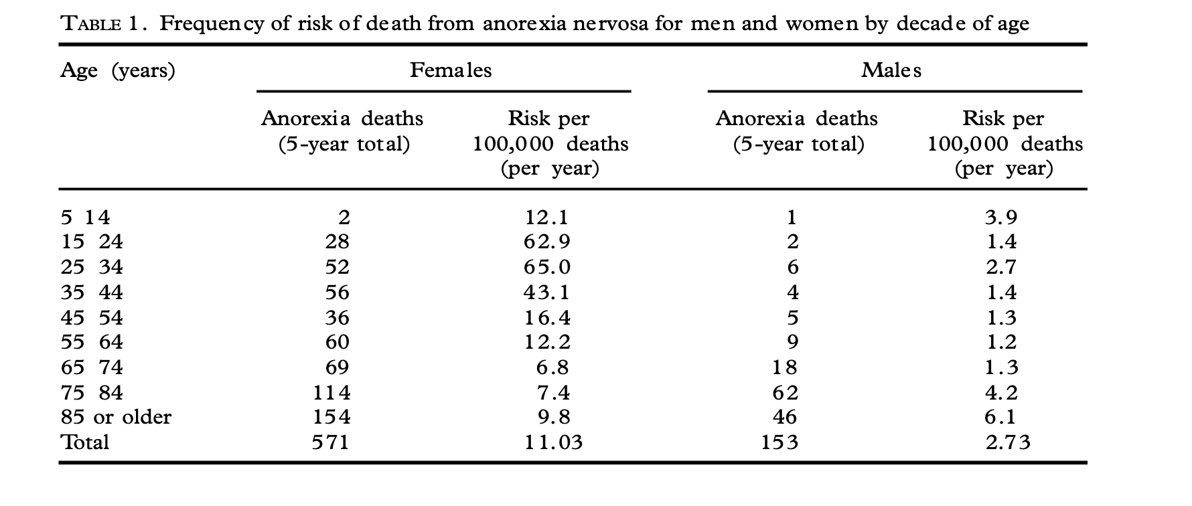
Table 1 death from distorted perception weight

Another tragic study, which shows the tragic impact of hateful words on peoples´ life, determined to show whether suicide rates among ethnic immigrant groups were predicted by the ethnophaulic, or the hate speech related to ethnicity [6]. The results support the expectation that suicide rates among ethnic immigrant groups in the USA would be predicted by the hate speech directed toward those ethnic immigrant groups.

Deep learning methods based on the artificial neural networks offers the most current optimal solution able to automatically detect and tackle hateful comments with high precision after training the network with a predefined class dataset, which have been investigated and will be explained thoroughly along this thesis.

Recently, Natural language processing (NLP) have paved the way for analyzing, processing and representing human´s language using theory-motivated range of computational techniques such as Word2Vec or Glove, which converts the twitter dataset into word vector representation, in order to enable the training of the neural network [7]. In depth, the introduction of Word2Vec by Mikolov et al [8] applying it on Long Short-Term Memory (LSTM) neural networks created by Hochreiter et al. (1997) [9] have provided the necessary tools to analyze humans sentiment. This thesis is focused on comparing BERT and Bi-LSTM model

Objectives

The main goal of this thesis is to explore and compare different machine learning and deep learning models for hate speech detection from social media achieved through following steps:

- Explore the history and the basics of neural networks and Transformers in the field of NLP.

- Perform a summary on the progression of research in hate speech detection through past papers.

- Build a classical statistical model to binary classify tweets as a reference for comparison with the other models.

- Build a 2-layer Bi-LSTM neural network model for hate speech classification on twitter dataset.

- Develop the BERT model, by tuning it on the twitter dataset, for hate speech classification.

- Perform error analysis on randomly chosen wrongly classified tweets samples from the previous models.

- Compare the model’s ability to binary classify the tweets into hateful or not based on the performance metrics.

Content description

This section is dedicated to providing a briefing about the content of the six chapters composing this thesis.
Chapter 1: It include the current chapter, which consists of the motivation behind the thesis as well as what´s new and challenging about it and its objectives.

Chapter 2: The main concepts and basics of the approaches used in the thesis has been covered in the background chapter.
Chapter 3: The state of art chapter includes the current achievements in hate speech detection in the NLP along with a timeline of datasets used in hateful detection.

Chapter 4: This section is tackling all the technical details related to the models as the dataset used, the type of pre-processing, the architecture of the models along with other technical stuff used.

Chapter 5: The evaluation chapter summarize the performance of the model and contains an error analysis with random samples of falsely classified tweets from Bi-LSTM and BERT models.

Chapter 6: The conclusion section composed of the judgment on the results obtained from the models as well as future work to be done for further enhancement on the topic.

Background

2.1 Artificial intelligence and Machine learning

According to Poole, Mackworth & Goebel, Artificial intelligence, which was interchanged with Computational intelligence at that time, is the as the study of intelligent agents, which consist of any device that perceives its environment and takes actions that maximize its chance of successfully achieving its goals. Under the umbrella of AI, machine learning is a branch of it, which consists if the study of building models based on mathematical model on a sample data known as the training dataset, which are used to predict future events without being dictated the outcome through programming [10].
There are four main types of machine learning:

- Supervised leaning: Supervised learning is a set of techniques that allows future predictions based on behaviors or characteristics analyzed in labelled historical data. Essentially, supervised learning techniques learn by example; therefore, the name supervised which originates from the idea that training this type of algorithms is like a person supervising the whole process. When we train an algorithm, the training data consists of inputs paired with the correct outputs. The prediction obtained is represented by means of a function where the inputs represent the analyzed characteristics and the output represents the variable to be predicted. This output function is either numerical in regression problems or categorical in classification problems [11].
- Unsupervised Learning:
This method is useful for exploratory analyses purposes since they can help us find previously unknown patterns in a dataset without pre-exiting labels. One of the main methods used in unsupervised learning techniques is cluster analysis, which is used to find data clusters such that each cluster has the most closely matched data. That is, clustering helps us group, or segment, datasets with shared attributes in order to extrapolate algorithmic relationships. In other words, clustering allows us to identify similarities in the data and reacts based on the presence or absence of such similarities in each additional chunk of data. In addition, it is useful to detect anomalous data points that do not fit into either group (Roman, 2019) [12].
- Semi-supervised Learning:
It´s a hybrid between supervised and unsupervised learning, in which some of the training instances are missing the training labels.
- Reinforcement Learning:
This technique is not relying on learning from data labels as in the supervised method, but on cumulative reward-based software backed [13].

In our case, supervised learning has been applied using neural networks and classical statistical models as Logistic classifier as a reference.

2.2 Deep Learning

Deep learning is a branch of ML, which rely on artificial neural networks or neural networks (NN) to learn data and predict future outcomes. Inspired by the human brain and how it works, the “neuron” in a neural network is a mathematical function which gathers and classifies information based on a specific architecture [14].
In Figure 1, the perceptron, which was introduced by Frank Rosenblatt in 1957, learns based on the MCP neuron model. In human nervous system, the neuron takes electrical signals from its dendrites in order to give the one right response. Similarly, the perceptron algorithm gathers information from many nodes in order to learn, process and classify the information into predefined classes. As shown in the figure, the perceptron classifies the input instance into class 1 while the neuron on the right gives an electric response to a specific muscle to contract.

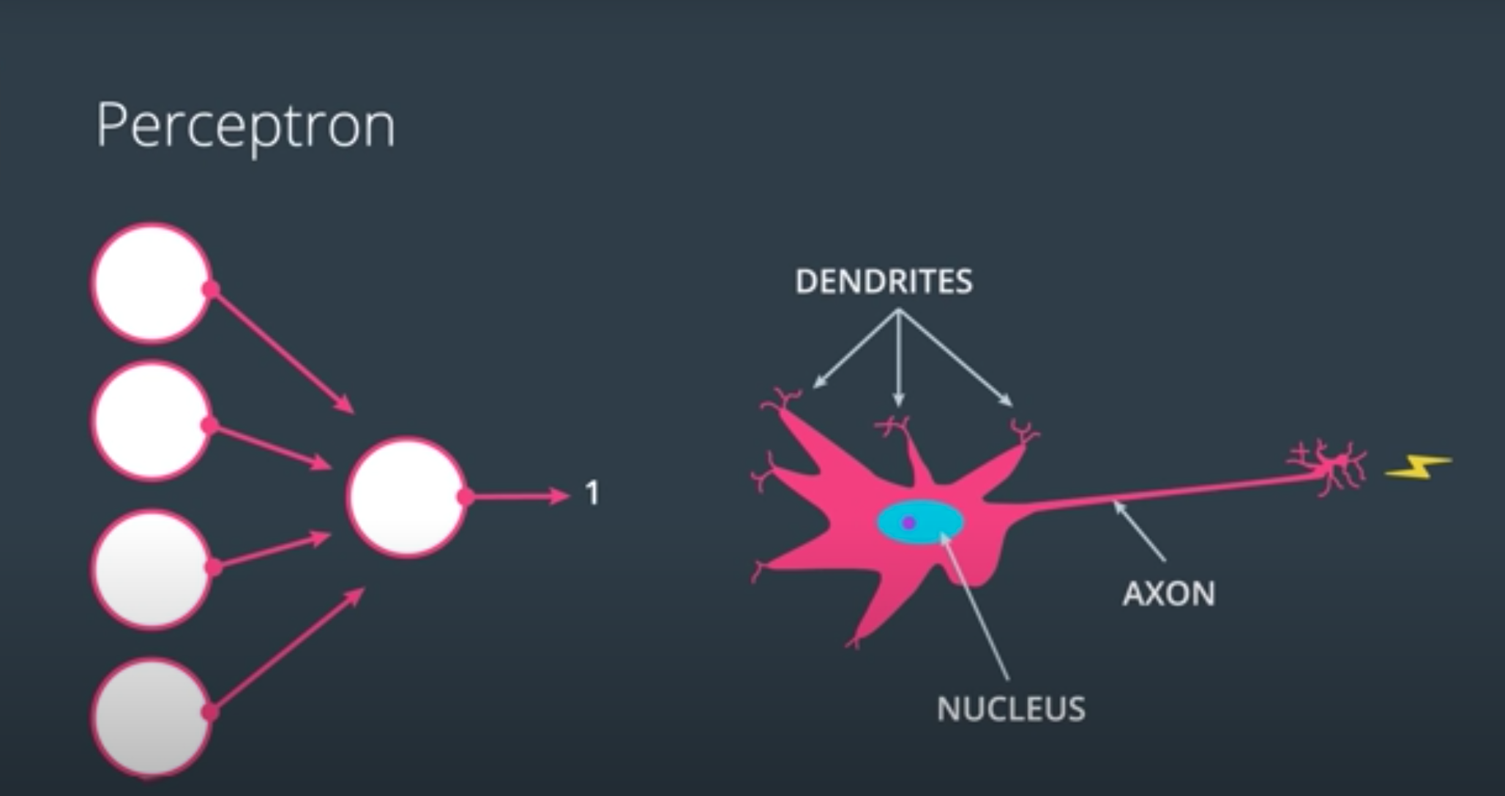
Figure 1 Perceptron similarity with biological neuron

2.2.1 Perceptron Model

The neural network is formed after concatenating several perceptron together so that the output of a perceptron is the input of another one. There are 2 types of perceptron:

- Single layer perceptron, which can only learn linearly separable patterns.
- Multilayer Perceptrons, which on the contrary, have higher processing capabilities for classifying highly complex data.

Then, the algorithm learns the optimal weights of the input signals for the sake of constructing a linear decision boundary in order to classify it into a class. Then, the learned weights are combined linearly with an input signal before using the Heaviside function as activation function, which will be explained later. Mathematically, its represented in equation 2.1 with w as the weights, x as the input signal, b as the bias, H as Heaviside function.

$\hat{y}=H\left(w^{T}x+b\right)$ 2.1

The Heaviside step function takes the shape shown in Figure 2:

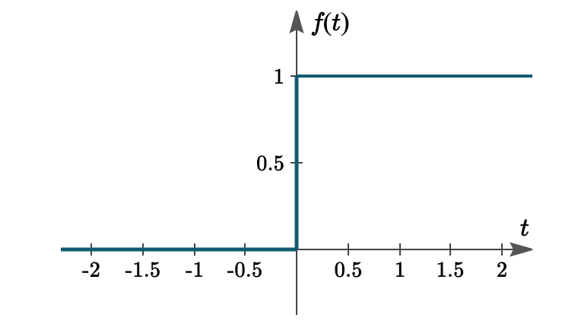
Figure 2 Heaviside step function

In some textbooks, the Heaviside function is represented as equation 2.2

$H\left(x\right)=\left\{\begin{matrix}1 x≥0 \\ 0 x<0\end{matrix}\right.$ 2.2

Figure 3 shows the various staged of the neuron model.
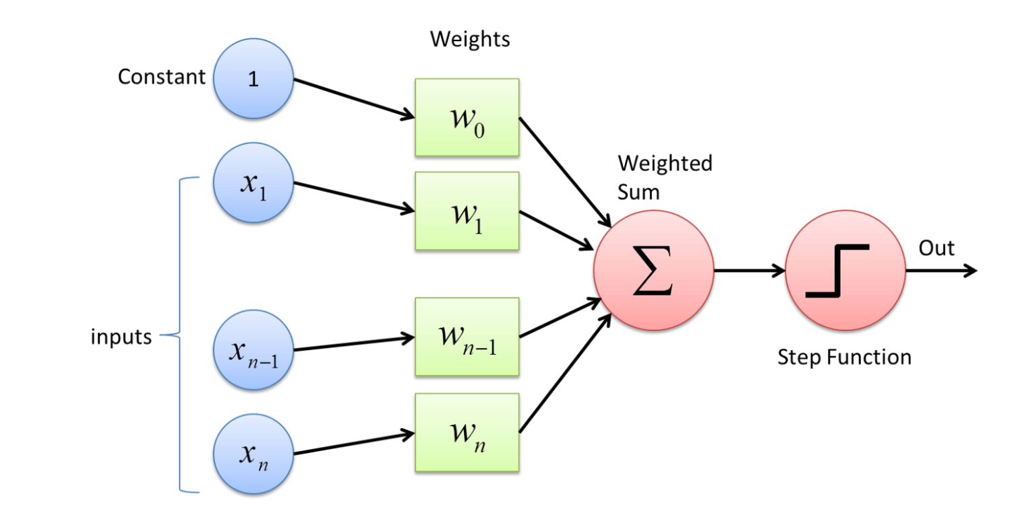
Figure 3 Neuron model [15]

2.2.2 Activation function

The purpose of this function is simply to get the output of the node between -1 and 1 or 0 and 1, depending on the function, for controlling the degree of activation of the perceptron when input is multiplied by the weights. Therefore, the activation function H of the perceptron in equation 2.1 was a Heaviside step function. However, there are other activation functions f in equation 2.3, as shown in Figure 4, which could be a linear or nonlinear function.

$\hat{y}=f(w^{T}x+b)$ 2.3

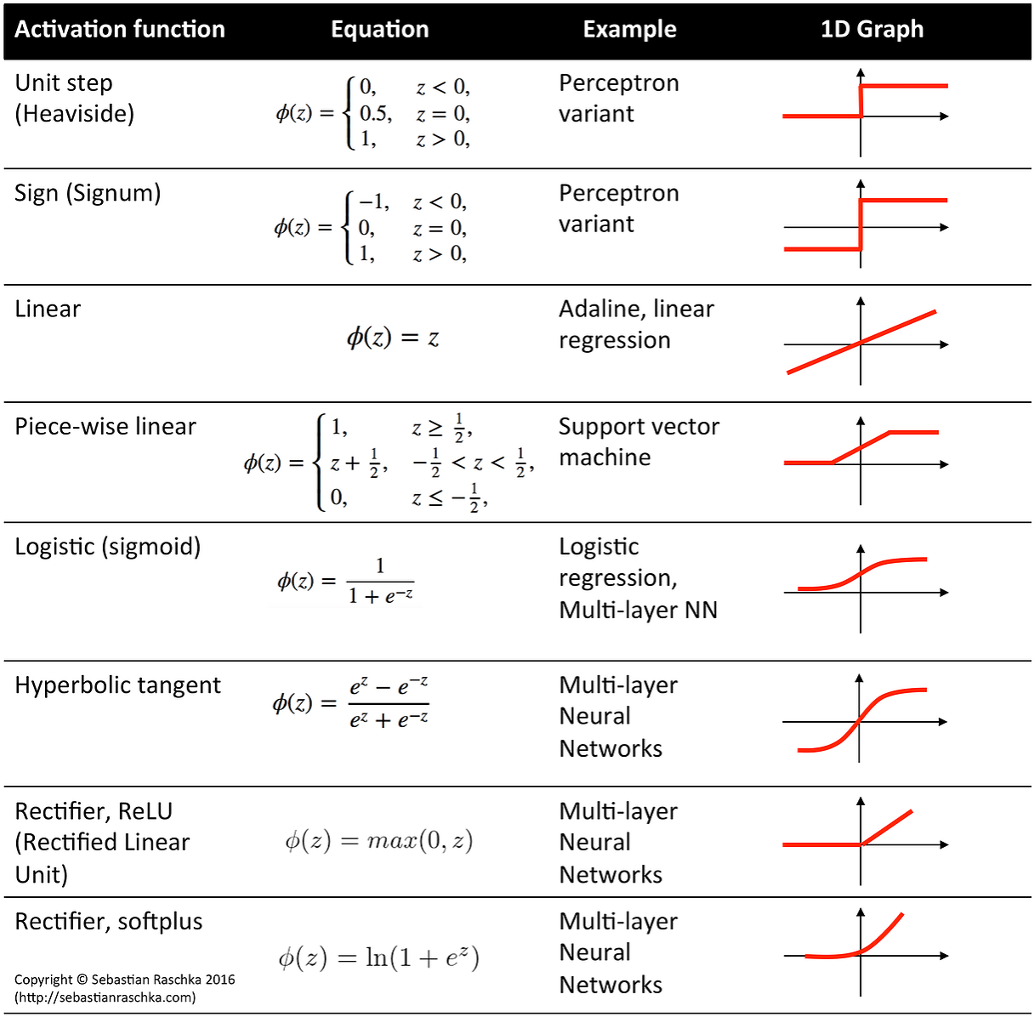
Figure 4 Activation function examples by Sabastian Raschka

2.2.3 Neural Network

More complexity is added by combining many neurons forming a multilayer perceptron (MLP) as shown in figure 5. The perceptron’s´ layer receiving the input signal directly is called input layer, before being passed to another hidden layers of perceptron, 2 layers shown in figure 5, each containing a number of neurons depending on the design. Finally, the output layer of perceptron receives the signal from the hidden layers in order to give the final classification of the signal of the output.
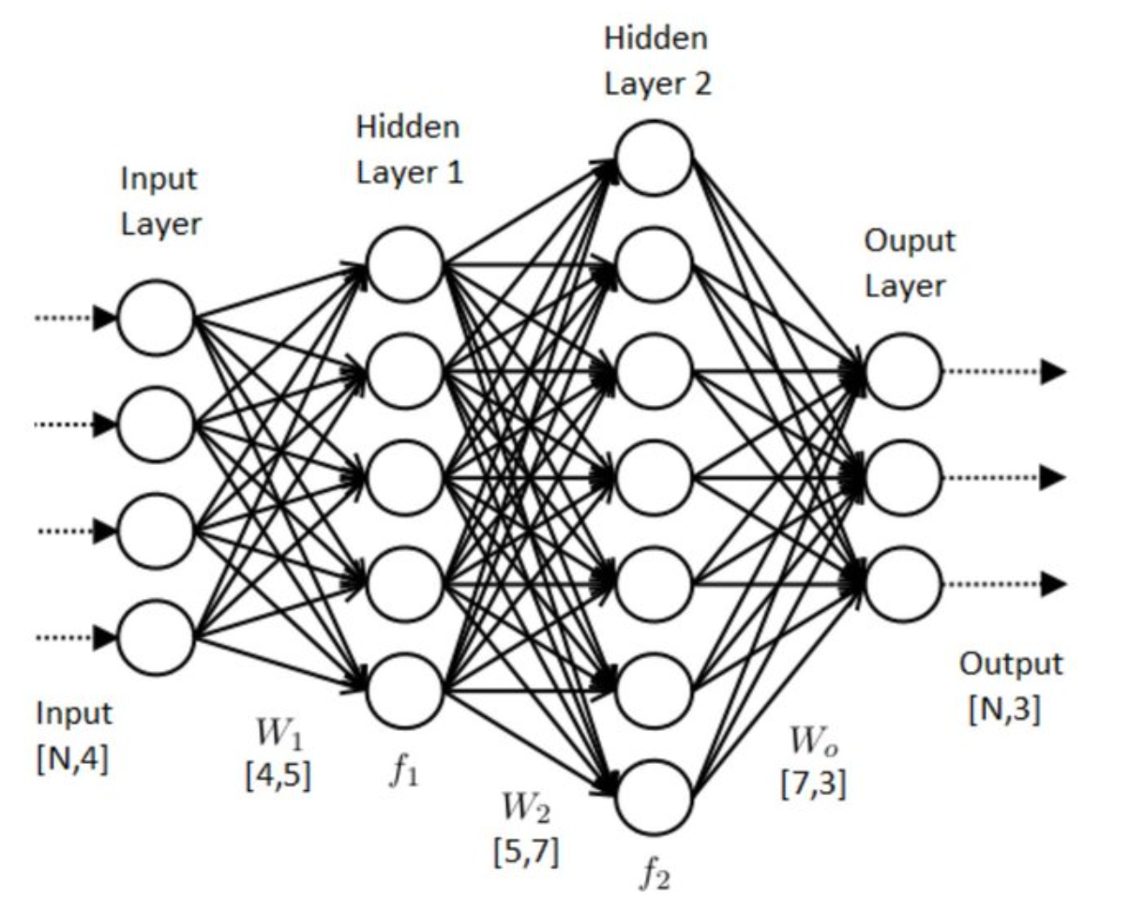
Figure 5 neural network designed by Paulo Vitor Campos Souza [16]

According to the paper published Shamir et al. [17], It shows that adding more hidden layers in the neural network allow it to gather mode deep information from data. On the contrary, increasing the number of neurons in one hidden layer cause the network to memorize the train dataset resulting in overfitting.

Loss Function

During the training phase of the neural network, an output $\hat{y}$ is produced when input data is provided according to the neurons´ weights learned. The loss function goal is to contrast the value of $\hat{y}$with the actual label y. Therefore, it tunes the weights of the neurons in a way to minimize the loss function as much as possible.

An example of loss function is the mean square error shown in equation 2.4 and cross-entropy loss formulated in equation 2.5.

$MSE=\frac{1}{N}\sum_{i=1}^{N}{{(y-\hat{y})}^{2}}$ 2.4

Cross-Entropy loss$= - (y\log{\hat{y} })+(1-y$) log (1 $-\hat{ y}$) 2.5

The weights of the neurons are tuned using gradient descent method in a way to minimize the output of the loss function as much as possible using the training dataset. Firstly, initial values of weights are chosen as a start. Then, the gradient of the loss function is calculated with respect to the weights until it reaches local minima i.e. convergence. The weights at convergence are saved in order to be used for future predictions on the test dataset.

2.2.4 Regularization

Overfitting is a familiar obstacle in Machine learning, which occurs when a model memorizes the training dataset instead of learning from the features within the predictors. As a result, the model become less generic to future input data. There are 2 Techniques being used in machine learning in order to overcome overfitting as much as possible to achieve a more accurate result:

- Dropout: The idea is to turn off or dropout some randomly picked neurons with probability p of the Bernoulli distribution. In depth, at each instance of a batch used for training, all neurons have a probability p of being turned off. The dropout happens only during training; not in testing [18].

- Early Stopping: At each epoch during training, another partition of the dataset called the validation dataset is used to measure the loss function. There will come a point in which the loss of the training dataset continues to decline but the loss of the validation dataset reaches a local minima just before increasing back again. The technique force training to stop at that point, to avoid overfitting on the training dataset.

Recurrent Neural Network (RNN)

RNN is a type of Neural networks, which are designed to meet some unit requirements as:

- Processing input sequence with any length.
- Previous information is taken into account for computing new outputs.
- Parameters as weights are shared along time across the sequence.
- Increasing the size of the input doesn´t affect the model size.

From its name, RNN are named as recurrent since the output of a network are allowed to be used as input while having hidden states as shown in figure 6.

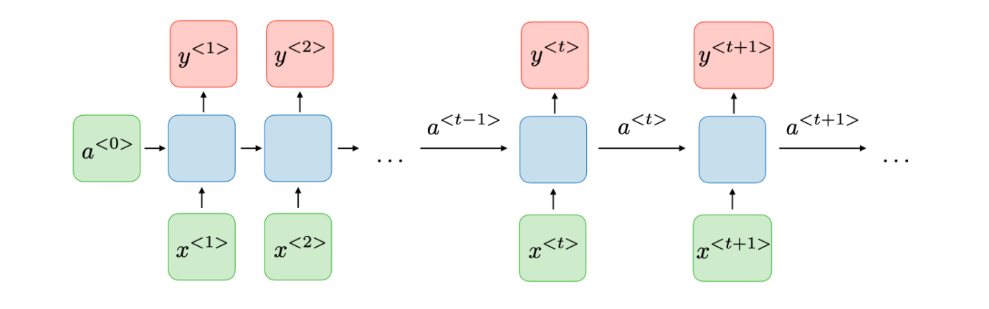
Figure 6 RNN model [19]

At each timestep t, activation $a^{<t>}$ and output $y^{<t>}$ are formulated within the mathematical equations 2.6 and 2.7. This allow the network to remember features from previous inputs.

$a^{<t>}=f_{1}(W_{aa}a^{<t-1>}+W_{ax}x^{t}+b_{a})$ 2.6

$y^{<t>}=f_{2}(W_{ya}a^{<t>}+b_{y})$ 2.7

In depth, $f_{1}$ and $f_{2}$ are activation functions, while $W_{aa}$, $W_{ax}$ and $W_{ya}$ are the weights applied to the input , the “cell-state” $a^{<t-1>}$ or current activation $a^{<t>}$ . Moreover, $b_{a}$ and $b_{y}$ are the bias terms in the formula show in figure 7. Therefore, the output y is dependent on the input at a timestep $x^{t}$ as a well as the cell state $a^{<t-1>}$.
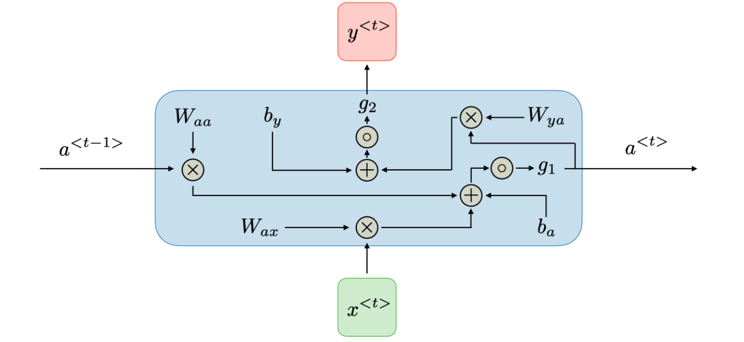
Figure 7 inside each block of a RNN [19]

2.3.1 Long short-term memory (LSTM)

Traditional RNN experience a phenomenon known as the vanishing gradient, which occurs during backward propagation when the partial derivative of the error function with respect to the current weights is negligibly small. As a result, the weights will cease to change, which causes the model to stop learning [20]. Therefore, RNN are not suitable to learn long distance correlation in the sequence. Fortunately, LSTM was created to tackle the issue of learning long-term dependencies in the data [21].

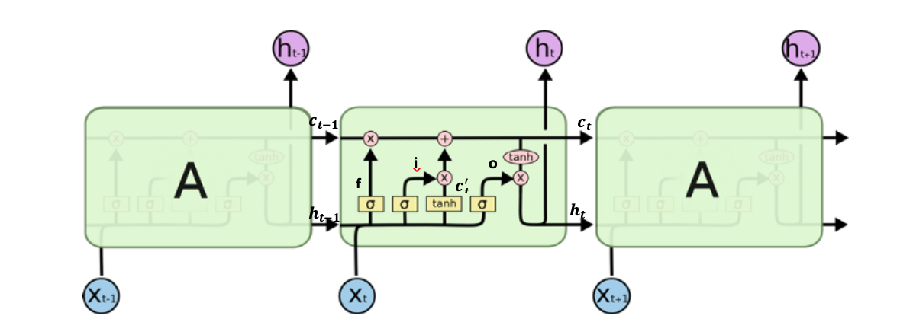
Figure 8 LSTM cell Design [22]
LSTM is a kind of RNN designed in a way to fit the purpose to remember information for long time. Accordingly, the repeating unit is become more complex design of RNN, as shown in figure 2.8, which retain information through the cell state. Information is passed unchanged along the LSTM through the cell state until gates regulate the addition or removal of information. These gates consist of sigmoid neural net layer with a pointwise multiplication, which return a value between 0 and 1 depending on which information desired to be remembered. A zero means don’t pass all the information while a one means completely pass all of it. Therefore, gates can forward only relevant information needed to make future predictions. There are three types of gates which will be explained in the following section.

Forget Gate

This gate is the first contact of information inside the cell, which is responsible for old information need to be memorized. At each timestamp, the gate decides the amount of unnecessary information, which need to be forgotten. In order to do so, the previous cell state $h_{t-1}$ is passed into the sigmoid function of the gate along with the current input data $x_{t}$. The output is calculated inclusively between 0, which means forgetting previous cell state and 1, which means remembering all the past information as shown in figure 9.

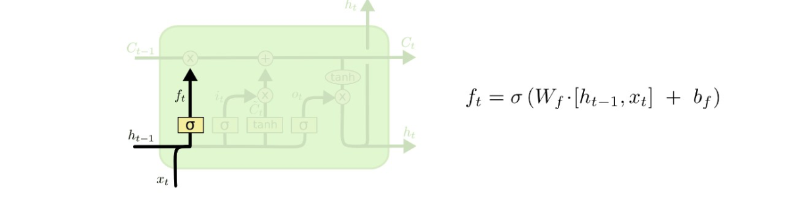
Figure 9 Forget gate [22]

Input Gate

This gate is responsible for adding an amount of information to the cell state. Firstly, a sigmoid function is used, similar to the Forget gate, to choose which values will be updated. Secondly, a tanh function is used to create a vector of values, which will be combined with output of the first stage creating an update to the cell state as shown in Figure 10.

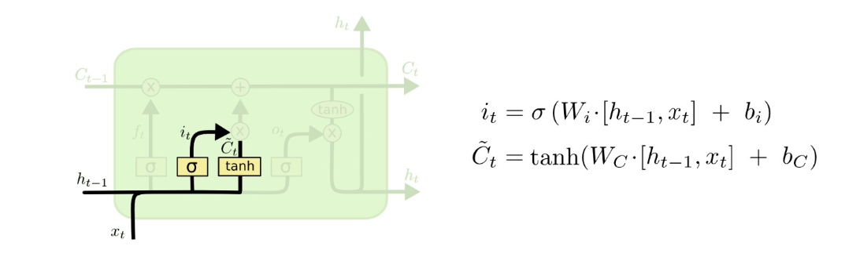
Figure 10 Input Gate [22]

The new cell state can be calculated now after adding the output of the forget gate with the input gate as shown in figure 11.
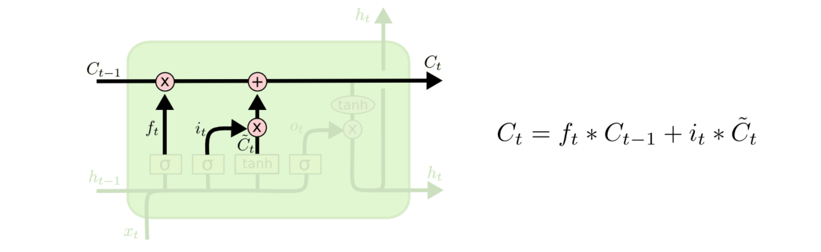
Figure 11 current cell state [22]

Output Gate

This gate is responsible for deciding the part of information in the cell state is going to be presented in the output. Also, a sigmoid function is used to filter the information in order to determine what information will be presented as an output from the cell state as shown in figure 12. The cell state is passed through a tanh function, which gives it a value between -1 and 1, before multiplying it with the output of the sigmoid part.
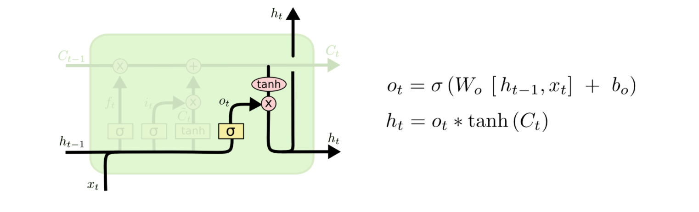
Figure 12 Output gate [22]

In this thesis, Bidirectional LSTM is used to achieve higher accuracy in prediction. The bidirectionality design of this RNN allow it to learn information from the past (backwards) and from the future (forward) through the two hidden layers connected separately as shown in figure 13.

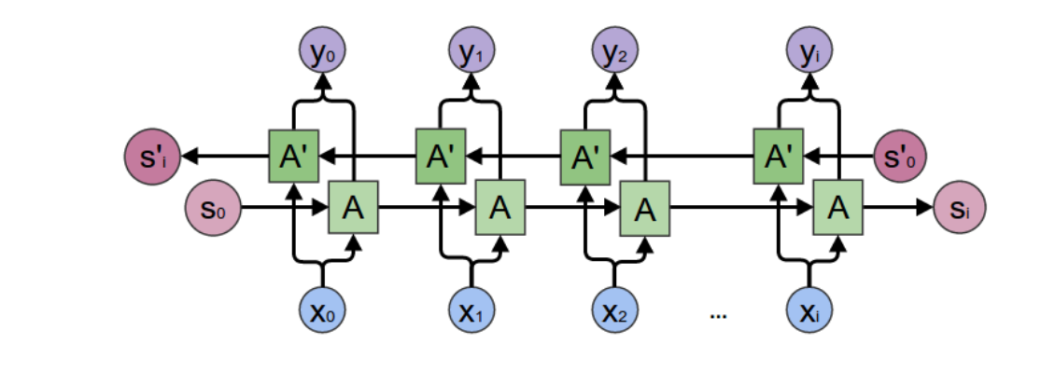
Figure 13 Bidirectional LSTM [23]

BERT

Bidirectional Encoder Representations from Transformers (BERT) is a breakthrough in the field of NLP, which was designed is created by Jacob Devlin and his colleagues from Google in 2019 [24]. On 25th of October, Google announced that applying BERT to google searches help them significantly in better understanding the search in order to provide the most suitable results in the US [25].

BERT is a bidirectional model, which is able to learn the whole sequence of words by taking into consideration the previous and the preceding simultaneously unlike the directional network, which learn the words sequentially in one direction either from right to left or from left to right. Therefore, it would make more sense to consider BERT a non-directional model since it read the text all at once non sequentially unlike Bi-LSTM, which achieve bidirectionality by combining right to left with left to right learning directions sequentially. BERT´s architecture enable it to understand the context of the sentences more than any other model, which will be explained thoroughly in the following section.

2.4.1 Transformers
BERT relies on Transformers based solely on attention mechanism to be able to read the whole sequence of words at once rather than sequentially [26] [24]. This way enables BERT to model the context of the sentence by knowing the context of a word based on its neighboring words in both directions. The Transformer consists of two separate Mechanisms. Firstly, an encoder, which is responsible for reading the sentences. Secondly, a decoder, which predict the outcome based on the task.
BERT´s input is being Embedded in a special way, which consist of 3 stages as shown in figure 14. The output of these three stages are added together to form the input of BERT model.
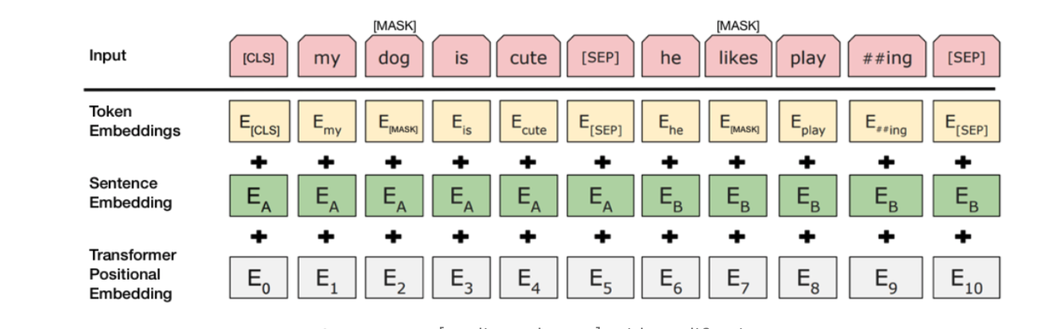
Figure 14 BERT input [24]

- Token Embedding
Similar to other NLP techniques, BERT´s input words have to be converted from text into a vector representation in order to be processed though the model. There have been many techniques developed for that purpose such as word embedding, which is one of most popular techniques that convert each word into a number containing information about the meaning of the word, its context and relationship with other words, which can be contrasted using word2vec technique developed by Mikolov et al. in 2013 [8] or using GloVe developed by Jeffrey Pennington et al. in 2014 at Stanford university [27]. However, BERT uses WordPiece technique for word embedding. WordPiece is using Huffman encoding as a method for tokenization using the principles of the game theory, in which more rare tokens (words) are included more in the vocabulary unlike other classical word representation. Apart from the rare token inclusivity, WordPiece is similar to Byte Pair Encoding (BPE) proposed by Sennrich et al. in 2016 [28]. Moreover, in order to handle slang words, which is labeled as out-of-vocabulary (OOV), words are split further as in the example in Figure 2.14, “playing” has been split into “play” and “ing” tokens [29].
For the sake of distinguishing between sentences, a [CLS] token is added at the beginning of a sentence while a [SEP] token is added at the end of each sentence.

- Segment Embedding
This embedding is responsible for representing information about the relationship between sentences as classifying how similar semantically two sentences are. Each sentence is will have another vector representation besides its consistent word representation.

- Position Embedding
Since the position of a word in a sentence can crucial carry information that need to be represented, the position embedding do this task. For example, in complex philosophical sentence as “I think, therefore I am”, the first “I” is different that the second “I” so each I should be represented with different weights due to their different positions in the sentence.

2.4.2 Masked LM (MLM)

BERT should be trained bidirectionally instead of the shallow concatenation of a left-to-right and a right-to-left model. Accordingly, some random tokens are chosen to be masked then predict masked tokens. BERT architecture consists of 2 stages known as pre-training and fine-tuning.
In the original paper, 15% of words’ positions are chosen randomly to be masked. However, this create a mismatch between the pre-training and fine-tuning because fine-tuning doesn´t contain the [MASK] token. To overcome this as much as possible, the “masked” words are not always replaced with the [MASK] tokens, the 15% of chosen tokens are replaced with the following [24]:

- A [MASK] tokens with a probability of 0.8.

- A random token with probability of 0.1.

- An unchanged token i.e. tokens left unchanged with probability of 0.1.

2.4.3 Next Sentence Prediction (NSP)

Another aspect of BERT model is to predict the relationship between sentences. The model is designed to predict how likely a second sentence is the subsequent one in the original data. Therefore, BERT is designed to receive pairs of sentences during training, which are 50% of the time an unchanged subsequent order of the sentences, while the other 50% are randomly constructed sentences paired from the dataset.
The probability of next sentence is precited using a SoftMax function. Accordingly, MLM and NSP are learned together with the goal of minimizing the loss function for higher accuracy.

2.5 Evaluation metrics

In the hateful comment detection study being conducted in this TFM, the model trained should be a binary classifier since the expected output should indicate whether the text is hateful or not. A positive class means that the comment contains hateful content while a negative class means that the comment is free from hateful content.
After the model classifies the comments of the training dataset, the output can be represented through the confusion matrix, which give an indication how accurate the model performed.

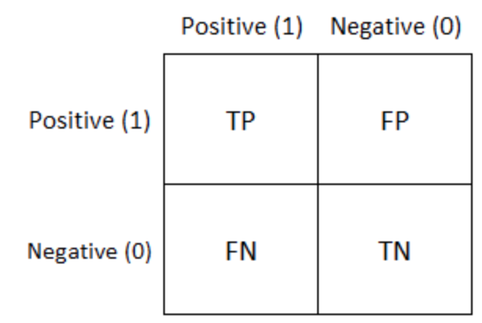
Figure 15 confusion matrix

The abbreviations in the matrix in Figure 2.15 means the following:
- True Positives (TP): number of positive instances (hateful comments) classified correctly.
- True Negatives (TN): number of negative instances (neutral comments) classified correctly.
- False Positives (FP): number of negative instances wrongly classified as positive i.e. neutral comments classified as hateful
- False Negatives (FN): number of positive instances wrongly classified as negative i.e. hateful comments classified as neutral.

Several metrics, which will be explained in this section, have been calculated in order to measure the model´s performance in classification and compare it with other models.

Accuracy:

It is the ratio of right prediction relative to the total number of instances.

 | $$Acc= \frac{TP+TN}{TP+TN+FP+FN}$$ | (2.51)

Precision:
The ratio of Hateful instances correctly classified relative to all positive predictions of the model.
 | $$Precision= \frac{TP}{TP+FP}$$ | (2.52) | $$Precision= \frac{TP}{TP+FP}$$
Recall:
The formula for calculating the recall is shown below, which calculate the metric responsible for measuring the model effectiveness in predicting hateful comments.
 | $$Recall= \frac{TP}{TP+FN}$$ | (2.53) | $$Recall= \frac{TP}{TP+FN}$$

F1-Score:
F1 score is the harmonic mean of Precision and Recall, which is useful when comparing models in cases the precision enhanced while recall deteriorates and vice versa.
$$F1= 2*\frac{Precision*Recall}{Precision+Recall}$$ | (2.54)

State of the art

The task of hate detection is not an easy one, even for humans. The reason for that is that there is not universal legal definition of hate speech. Whenever people having a strong opinion about a topic, there is a risk of being offensive. Is that considered as hate speech? To make it more complicated, if a clinical psychologist is saying on TV that women statistically more agreeable so they are more likely to be payed less than men since they are more content with what they get, will it be hateful or scientifically evident opinion?

The united nations has defined hate speech as “any kind of communication in speech, writing or behaviour, that attacks or uses pejorative or discriminatory language with reference to a person or a group on the basis of who they are, in other words, based on their religion, ethnicity, nationality, race, colour, descent, gender or other identity factor. This is often rooted in, and generates intolerance and hatred and, in certain contexts, can be demeaning and
divisive. ” [30].

The purpose of hate detection on text is to weed them out before being reached by people through the social network. On 8th of September 2020, Facebook engineer quit Facebook for protesting the non-removal of Donald Trump´s post "when the looting starts, the shooting starts,”, which was targeted on black protested who start stealing shops. Moreover, he stated that Facebook failed to remove an event that called for violence against Black protesters in Kenosha, Wisconsin [1] causing protest shootings. Despite Mark Zuckerberg’s response, it is clear to classify the 2 incidents as hateful, which need to be removed from Facebook before calling violence.

In this chapter, a summary on the datasets used in hateful classification of text is compiled along with the most recent approaches.

3.1 Datasets for hate speech detection

A different dataset, developed by Petrocchi et al. in 2017, consists of 17,567 Facebook comments extracted using a Facebook crawler on 99 posts from 8 Facebook pages [31]. The comments have been annotated by 5 bachelor students into 3 classes: No hate, Weak hate, and Strong hate. Out of the 17,567 comments, the publishers chose 3,356 comments, in which each comment has been annotated by the 3 students with the existence of a majority class. The results show imbalanced classes of the comments as the following:

- 2,816 comment as No hate.
- 410 comment as Weak hate.
- 130 comment as Strong hate.

The SVM model is compared with LSTM on their binary and multiclass classification performance. In the case of Binary classification, both weak and string hate are merged together obviously.

On the other hand, Grondahl et al. argued that models work good only on the type of data they are trained on. Evidently, they proposed that the model architecture is not as important as the data type and its labelling method [32]. Accordingly, 5 different datasets have been used as shown in table 2, with their sizes. In my opinion, Dataset W is different and odd, not because of its different source, but because its labelling Wikipedia’s edit comments into personal attacks class not hate, which the border line between neutral and hate hazier. However, the fact that annotation was labelled by 10 annotators from crowdsourcing from Wikipedia’s “Detox” project makes it more reliable.

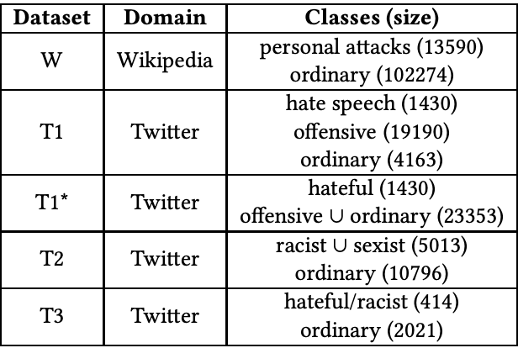
Table 2 list of datasets [32]

In 2019, Azimi et al. did their hate sentiment analysis on a database collected from the famous movie review website IMDB. The dataset consists of 50k movie reviews classified into equally balanced binary classes of positive and negative , while making sure that there is no more than 30 reviews for one specific movie [33]. Critically, the having a negative label on a movie review doesn´t necessarily mean its hateful speech as it could be just a criticism about an aspect of the movie.

Similarly, hate detection in other languages has been tested like Arabic done by Nikolov et al. in 2019. The dataset consists 15,050 Arabic YouTube comments from Arabic celebrities’ videos and annotated either offensive or not by 3 annotators, who need to have a major vote on each comment to be labelled offensive. The pre-processing of the Arabic language was more challenging than western languages due to the numerous dialects of the Arabic so Arabic letters have been stripped from extra accents- like punctuation. For example, letters “أ, إ, آ” have been replaced by its simplest form “ا”.

One of the most recent datasets picked, by Fohr et al. in 2020, for hate detection is a twitter corpus, which gathered 24883 tweets from hatebase.org [34]. Each tweet is classified into one of three categories by CrowdFlower:

- hate speech which represents 5.7% of the data.
- offensive language, which represent 77.1% of the data.
- Neither, which represents 16.7% of the data.

Not only a binary classification model is created with BERT and Bi-LSTM by combining the hate speech and the offensive language, but also a multiclass classification is performed into the three classes mentioned above. The data is cleaned by removing retweets symbols “RT”, usernames starting with “@username”. Also, Hashtags have been extracted and split into meaningful words. For example, #blacklivesmatter is transformed into black lives matter.

3.2 Cutting edge approaches in hate detection

The most advanced state of art model in NLP is BERT, which has been explained thoroughly in the background section. Proceeding the announcement of BERT, Google announced a multilingual BERT model able to process 104 languages [35]. mBERT is model which is fine-tuned based on the cross-linguality, which is the influence of languages on each other, by the help of a technique known as Zero-Shot Transfer Learning to find a shared space. For example, the English word “desk” and its German synonym “Tisch” is derived from the Latin word “Discus”. Figure 16 shown the similarities found in 3 couples of languages. It´s obvious that English and Deutsch reached 75% match in representation. However, there is a paper published by Perez et al. [36], which was able to tune BERT pretrained model on big Spanish dataset achieving more accurate results than mBERT.

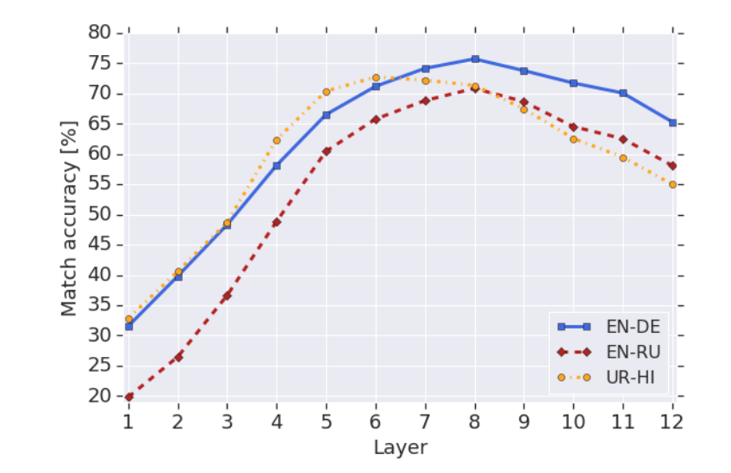
Figure 16 Cross-linguality nearest neighbor accuracy within 5 languages [35]

4. Hateful Detection using Bi-LSTM and BERT

After summarizing their mechanisms in section 2, a thorough explanation on architecture of the two most precise up-to-date techniques used in hateful detection of texts, Bi-LSTM and BERT is shown in this section, along with other technicalities concerning the dataset.

Dataset

The first dataset used consists of 32 thousand tweets gathered from twitter over a specific period of time. These tweets have been classified and labelled into hateful and neutral tweets. Within this time period, the majority of tweets were not classified as hateful making the dataset imbalanced as expected. From the 32 thousand tweets, 29720 tweets were neutral while the other 2242 tweets contain hateful content. The histogram plot in Figure 17 visualize the difference in counts between the two classes.

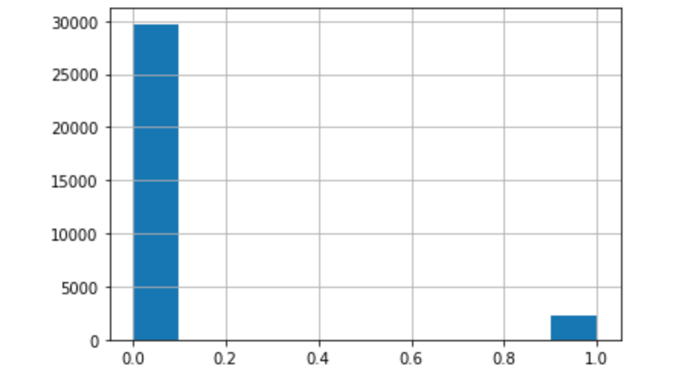
Figure 17 Histogram of comments label
The structure of the training dataset consists of 3 columns:

- The serial ID of the tweet(phrase_ids).
- The tweets 140 characters of the tweets (Phrase).
- The hateful sentiment label of tweet i.e. “1” for hateful tweet and “0” for neutral(sentiment_values).

Unfortunately, tweets contain spelling mistakes, non-useful hashtags, usernames and slang abbreviation of sentences, which contains misguided or distracting information during training the mode. Accordingly, the pre-processing part was challenging in order to clean the tweets as much as possible.

Data Preprocessing

The observed human statistics indicates that for every 100 tweets written, 8 will contain hateful content. Despite the fact that the imbalance between the 2 classes simulates real life behavior of people, it could create a bias in classifying most tweets as neutral since that’s most probable class. Therefore, class weights have been adjusted in order to give more weights to the minority hate tweets. Also, SMOTE technique has been used for oversampling the hateful tweets, which achieves better classifier performance in ROC space [37].

Moreover, hashtags and usernames are removed from tweets using python libraries tokenizer with specific regex when tokenizing the words. Furthermore, all tweets have been converted into lower case earlier. It’s worth mentioning that no stop words have been removed, which are common practice with text classification. The reason for that is, the neural network and BERT models are tested to check their extent of understanding the context of the sentences, so it makes perfect sense not to remove pronouns or any Stopwords.
Finally, the dataset has been partitioned into three separate CSV files for training, validation and testing purposes with the following ratios as the following:

- Train: consisting of 80% of the tweets, which is 25533 tweets.
- Validation: consisting of 10% of the tweets, which is 3226 tweets.
- Test: consisting of 10% of the tweets as well which is 3206 tweets.

All of the three partitions are formed of balanced classes as stated earlier.

Bi-LSTM based model

After pre-processing, one of the classifiers trained is based on the Bidirectional LSTM as explained earlier. In this section, the architecture of the LSTM has been shown with some further technicalities.
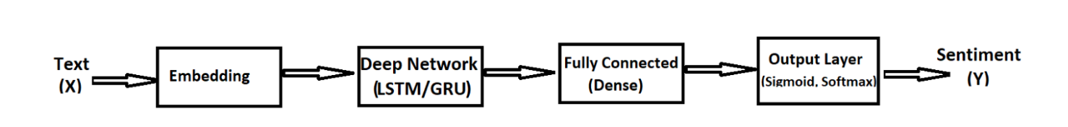
Figure 18 Deep learning Architecture

4.3.1 Word Embedding

Glove has been chosen for the vector space representations of the tokens since it outperforms related models doing the similar task [27].The pre-trained word vectors glove.6B.100d, which contains 6 B tokens of 400 k vocab forming a 100 dimension vector representation gathered form Wikipedia 2014 and Gigaword 5 corpora [27].

Words are then represented into a matrix using the glove pretrained file, which act as a lookup table. The glove representation is based upon an actual probability of occurrence of words together, which is represented in figure 19. These probabilities are actual ones form a 6-billion-word corpus:

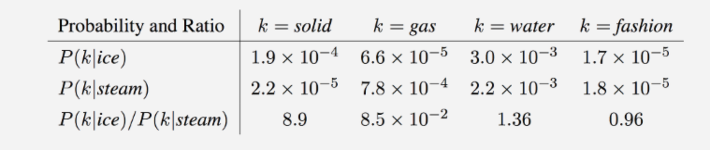
Figure 19 Glove probability table overview [27]

4.3.2 bi-LSTM network layer

The first classifier being used consists of three layers a bidirectional LSTM, a max-pooling and an output sigmoid output layer. LSTM is designed to process words in one direction either from left to right or from right to left. Therefore, two hidden layers are connected together, which can process the words in opposite directions forming the bidirectional LSTM. Accordingly, the model is able now to understand the context of sentences more as information from both directions are taken into consideration. Similarly, to show the importance of bidirectionality in an analogy, a film director in a crime movie knows at the end who is criminal, so he uses cinematics to convey that information from the beginning of movie through the actor’s sentiment expressions one at a time until the puzzle is revealed at the end.

Accordingly, Bi-LSTM has been chosen for classification since is outperform the unidirectional one is recognizing the information in the sentences, which is evidenced by Schmidhuber et al. [38].

The Bi-LSTM layer Consists of 128 units have been used in each direction based on previous work done by Chatzikyriakidis et al. [39].

4.3.3 Max-Pooling Layer

Max pooling layer is performing down-sampling by computing the maximum results of the input. Following the BI-LSTM layer, the LSTM cells generate results along the iterations, which are processed by the global Max-pooling layer to choose only the maximum result as an output. Accordingly, less important information in classifying whether a tweet is hateful or not are being weeded out by this layer.

4.3.4 Fully Connected Layers

The Fully connected layers are responsible for further feature extraction of the input data by compiling it, which is the preceding for the final classification of the text. After the Bi-LSTM and the max-pooling layer, a fully connected layer consists of 40 units with a dropout probability of 0.5. Furthermore, another fully connected layers of 20 units is implemented with same dropout probability as the previous layer.
Although most of the significant smart feature extraction are done by the Bi-LSTM layer, adding two fully connected layers have been widely used instead of one layer, which proved to enhance the classification performance slightly Bi-LSTM are much more important accuracy wise [40]. ReLU is the activation function in this layer because it tends to represent the information in a sparse way, which tends to make the model briefer with higher accuracy during inferencing.

4.3.4 Sigmoid Output Layer

The final layer is responsible for classifying the text into the binary hateful or neutral based on its probability. Depending on calculated probability, if it´s above 0.5 then its hateful since the output will be positive otherwise its neutral when the probability is below 0.5.

4.4. BERT
Alternatively, this section describes the BERT model used as a classifier with more technical details.

4.4.1 BERT encoder

Similarly, as the Bi-LSTM, all words have been converted to lower case as long as removing Diacritics. Then, words have been piecewise tokenized while masking randomly some tokens along with adding the [CLS] and the [SEP] tokens as explained in section 2.4. Moreover, the segments embedding is performed, comprised in the NSP, and added with the tokens and the masks forming the input for the BERT layer.

4.4.2 BERT layer

There are two model developed originally by Devlin et al. paper in 2019, which are made of different number of layers L, hidden size H and number of heads A. The First model was made for a specific comparison needed in the paper called ${BERT}_{base}$ , which is why it has been discarded. The second model has been used as the classifier called ${BERT}_{large}$, which have L=24, H=1024, A=16 and total Parameters=340M [24]. A pre-trained model in English made from Wikipedia and BooksCorpus has been loaded from Tensorflow hub [41], which implements the ${BERT}_{large}$ model from the TensorFlow Models repository on GitHub [42]. In this way, the BERT pretrained model can be integrated easily as a Keras layer preceding the sigmoid output layer, which give the probabilities of the binary classes.

4.4.3 Output layer

Typically, this layer receives the output from the BERT layer before passing it to the sigmoid function. The output of the sigmoid function determines the class of the instances depending on the probability of each class. This layer is made up of one unit with a sigmoid activation function as explained in the Bi-LSTM section.

4.5 Regularization

The typical problem in the field of data science, which happens during training a model is overfitting. Overfitting is literal learning of the training dataset instead of generalizing the behavior it. After a specific iteration, the model begins predicting more accurately the outcome of the training dataset but less accurate on any other dataset. That’s because the model starts to memorize the training dataset instead of generalizing it so that it can be used on new instances. In order to reduce overfitting as much as possible, regularization techniques have been used as follows.

Dropout

The dropout technique done involves dropping out curtain units from the network randomly and temporarily with a specific probability as discussed in the background section 2. [18].The probability P in the model has been set to 0.5, which means that there is a chance of 50 % of the unit to switch off along the timestamps, which reduce the overfitting of the data as shown in figure 20.

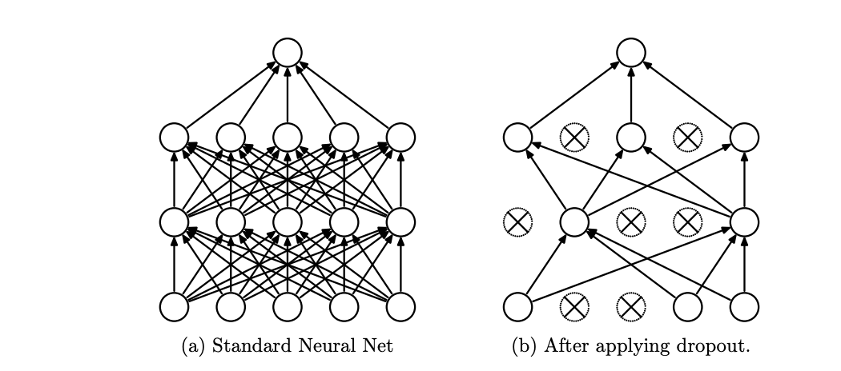
Figure 20 Dropout Neural network model [18]

Early Stopping

Early stopping technique have been set to check, after each epoch, the improvement upon the validation dataset. At the point when the validation dataset accuracy stops improving for 3 consecutive epochs, the model stops training to avoid the overfitting. Accordingly, the last model along with its optimal parameters is saved, which achieved the most accurate predictions on the validation dataset and used upon the testing dataset.

4.6 Network Training Details

Further technical details about the training methodology used has been further elaborated in this section. The neural networks are built using Keras library, which run on top of TensorFlow [43].

4.6.1 Optimizer

Alternative to the classical stochastic gradient descent, Adam optimizer, which stands for adaptive moment estimation, has been picked due to its efficiency in computation and memory storage as well as its good results in practice [44].Adam optimize the first order of the gradient, which explains its relative simplicity compared to other optimizers, which would compute the second degree gradients. The default arguments have preserved for both models, which are as the following:
- learning_rate: 0.001.
- beta_1: 0.9.
- beta_2: 0.999.
- epsilon: 1e-7.
- amsgrad: False.
- name: "Adam".

4.6.2 Loss

The loss is computed using the binary cross entropy, which was an easy choice to choose for binary classification relative to the alternative as Squared Hinge Loss and Squared Hinge Loss. With no doubt, it’s the default loss function for binary classifications.

Cross-Entropy loss$= - (y\log{\hat{y} })+(1-y$) log (1 $-\hat{ y}$) 4.1

Note in equation 4.1, if the target y is 1 for hateful instances, the second part of the equation will be cancelled. Similarly, if y is 0, the first part of the equation will be cancelled.

4.6.3 Epochs and batch sizes

The number of epochs in the Bi-LSTM and the BERT model were different due to their different architecture knowing that BERT model is computationally more expensive. Despite probing the total number of epochs in Bi-LSTM to be 25 and 7 in BERT, both have reached their optimal results on the 5th epoch using the early stopping technique.

4.7 Software and Hardware Details

The entire work of this TFM has been built using python language, which contains all the necessary libraries and kits needed to develop both models. Keras Library has been relied upon for constructing the neural network layers. Also, the open source library, designed by Google Brain team, has been pivotal in providing the pretrained BERT model needed to construct the second model. Moreover, the regular data science libraries were crucial in handling and presenting the data as sklearn, Pandas, numpy, and matplotlib.

It’s worth mentioning that Google Colab online environment has been used to compute the code in order to benefit from the provided high resources of computation through GPU instead of the domestic GPU or CPU.

Evaluation and Discussion

Both models have predicted the classification outcome on the test dataset using the specifications explained in section 4. Both models did a great job in classification compared to the classical reference model, which rely on logistic classification method. BERT in general shows substantial improvement in classification, making it stand out among other methods for providing the state of art results in classification so far. Although Bi-LSTM model has significantly better accuracy in prediction compared to the reference logistic model since the accuracy has improved 6%, BERT achieved higher accuracy than it with 2%. Moreover, BERT significantly enhanced the f1-score by 10% compared to the reference and Bi-LSTM models, which have almost similar scores.
The comparison between the three models have been displayed in table 5.1 below:

Model | Accuracy | F1-score | Precision | Recall | Loss
Logistic (ref.) | 0.88 | 0.69 | 0.66 | 0.79 | -
Bi-LSTM | 0.94 | 0.63 | 0.60 | 0.7 | 0.3
BERT | 0.97 | 0.76 | 0.70 | 0.74 | 1.2
Table 5.1 Model comparison

The complexity of this classification even for humans lies in drawing the line between freedom of expression and defense of the human dignity. It´s easy for us humans and the models as well to label a text as hateful when it´s attacking people based on their sex, race, religion, disability, sexual orientation or ethnic origin. For example, there is no hesitation to classify US president, Donald Trump, tweet “If Hilary Clinton can´t satisfy her husband what makes her think she can satisfy America” has hateful since he is attacking his opponents based on her gender [45]. However, some tweets are a bit harder to classify it since it lies in the thin line between being hateful and freedom of expression. In the following section, these falsely classified tweets, whether false positives or false negatives, have been gathered in order to analyze why the models found it difficult to classify it.

Error Analysis and Discussion

The purpose of this section is to determine the glitches in both models in classification of the test dataset and compare their outcomes to see whether BERT achieved better understanding of the context of the sentences or not. In order to do so, 5 tweets have been picked randomly from both false positives and false negatives as shown in tables 5.2 and 5.3 below from both models and see if who guessed it right.
Let’s examine the first tweet shown in table 5.2,” trump campaign: female judges could be biased, too he must hate women”, which have been falsely classified as hateful. The tweet is commenting about the statement made by US president Trump’s campaign about female judges could be biased due to being clouded by their emotions and saying that he must hate women. We were able to know the sentiment of the tweet since we have a background about president Trump, while both models don´t. Despite containing words as hate women, which may explain why both models label it as hateful, the tweet is about expressing an opinion about a public figure statement. The poor linking words and bad punctuation make it even harder to know that the sentence after the comma is casual to previous. Our brains can say the tweet is not hateful since it’s not targeting Mr. Trumps as a person by saying “I hate Trump”, yet it judges him logically based on the campaign statements.

To show how complex the classification can get, a tweet like “i can't stand a habitual liar man” can be very challenging of a model to predict despite being prediction correctly by BERT model. If this tweet is written in general, it won’t be considered as hateful since know body in the world can stand a habitual liar. However, if this tweet is sent to someone directly with a mention of his username in it, then it would be considered as hateful since it attacks a man by calling him a liar by habit. Bi-LSTM has fallen for the bait by falsely classifying it as hateful while BERT was able to notice the absence of a username mention (@user) probably, which is why it hasn´t been removed during pre-processing.

Similarly, a tweet as “@user why do you always have to slurr ppl. every time! every! im suprised you havent called me a racist” was challenging as well for both models to predict it non hateful. Besides the grammar mistakes and misspelling of words, it’s hard for the model to know that tweet is actually a reply on previous conversation thread, which the tweet sender is indirectly telling his receiver that he is falsely prejudging people with racism without proof. We can say that the tweet sender is not angry or hateful but off course non agreeing with another user.

False Positives

Tweets | Bi-LSTM | BERT
trump campaign: female judges could be biased, too he must hate women | wrong | wrong
I do not understand at what point @user will stop giving aiime to racist aven’t lord. I don’t get it @user @user #cheap | wrong | wrong
@user @user @user @user @user @user #americans have a right to be over this #massacre! | Wrong | wrong
@user why do you always have to slurr ppl. Every time! Every! Im I you aven’t called me a racist | wrong | wrong
I can’t stand a habitual liar man.. | wrong | right
Table 5.3 False Positives sample

On the other hand, some random false negatives have been examined and displayed in table 5.3. A tweet as “did you vote for this animal #trump's america: no fat chicks @user” has been falsely classified by both models as not hatful. Perhaps because the models didn´t comprehend the slag word chicks, which is referring to a young girl, instead the models understood the literal definition of the word, which means a young chicken. Accordingly, it won´t be hateful if u call a young chicken fat in a middle of conversation!

Another hard guess for both models was “why is it christmas eve? why not christmas adam?”, which surprisingly has been predicted right by Bi-LSTM and not BERT. Apparently, the sender of the tweet has a hateful sentiment toward women as he is wandering sarcastically why by convention people call it charismas eve, which is derived from the word “evening”, instead of Biblical Eve´s partner Adam.

Moreover, “goodbye 2016.... i definitely hope we leave behind” was falsely classified by both models. Despite containing positive words as goodbye, its understood that the user was sarcastic as he hates 2016.

False Negatives

Tweets | Bi-LSTM | BERT
did you vote for this animal #trump's america: no fat chicks @user | wrong | wrong
@user @user that's how you got in . by being an australian doing shitty things . | wrong | wrong
are you just takin' the piss now or | wrong | wrong
goodbye 2016.... i definitely hope we leave behind | wrong | wrong
why is it christmas eve? why not christmas adam? | right | wrong
Table 5.4 false negatives sample

Conclusion and future work

The purpose of this TFM is to achieve state of art results in hateful sentiment classification of text, which have been achieved through both models being compared. Despite their good performance, some future adjustment could enhance the results even further. In this section, conclusions and future improvements have been discussed to be done in the future.

It´s observed through performing the error analysis that BERT model produced the more accurate predictions, which has been claimed by Google as noted earlier in section 5.

Firstly, examining the dataset, detecting hate on social media website as twitter was filled with extra obstacles faced by the models as the spelling mistakes and slang words. Despite the fact that BERT deal with Misspelling using the Subword tokenization, which may help BERT to get useful information, slang words and abbreviation as TYT (Take your time) confuse both models by not providing the needed information during tuning. Moreover, Glove fail to embed out-of-vocabulary (OOV) words, which are numerous on social media. For that reason, Facebook has developed their own word embedding known as MOE, for Misspelling Oblivious Word Embeddings for handling misspelled words [46].

Moreover, regarding the twitter dataset, some instances are cut out of conversation thread of users replies to each other, which might not make sense unless the history of the conversation is known by the models and presented as a single instance with the username mention (@user). An example of this glitch can be clearly seen from the false positives and negatives. Accordingly, a dataset would be created which group all replies between users in one instance.

In the Future, a plan is made to create a bigger dataset with more than 500k tweets labelled as hateful or not, while compacting the users´ replies in one long instances. Also, a balance between hateful and neutral tweets will be considered from the beginning instead of handling this imbalance with techniques that add redundant information or remove valuable ones as oversampling the minority class or under sampling the majority class. With enough GPU resources, which could be provided through platforms as Google Collab or another cloud service provider, the models will be able to gather more information during tuning, which will enable them to predict hateful text more accurately.

There have been several papers involved training a neural network to predict the sentiment of text written in languages other than English. Typically, this is done through using a word embedding specific for this language to turn the words into its vector representation. For example, Arabic word embedding has been used in this study involving predicting hateful Arabic comments on YouTube [47]. However, this is not the case for BERT since its pretrained model is designed for English initially. Fortunately, there have been some impressive results for a model named BETO, which is a BERT model trained on a big Spanish dataset. BETO has been an initiative to bridge the gap between BERT pre-trained model and Spanish language. In the future, work will be exerted to create similar models for other languages as Arabic [36].

Works Cited

[1] | B. Insider, "A Facebook engineer just quit in protest, accusing the company of 'profiting off hate'," [Online]. Available: https://www.businessinsider.com/facebook-engineer-quits-accuses-company-of-profiting-off-hate-2020-9?r=DE&IR=T.
[2] | R. L. N. J. R. N. V. M. Z. P. M. P. D. &. S. W. Letter Published: 21 August 2019 Hidden resilience and adaptive dynamics of the global online hate ecology N. F. Johnson, "Letter Published: 21 August 2019 Hidden resilience and adaptive dynamics of the global online hate ecology," [Online]. Available: https://www.nature.com/articles/s41586-019-1494-7.
[3] | I. Gagliardone, D. Gal, T. Alves and G. (. Martinez, "Countering Online Hate Speech.," [Online]. Available: https://unesdoc.unesco.org/ark:/48223/pf0000233231_eng.
[4] | 1. S. C. &. G. D. S. P. L. HEWITT. [Online]. Available: https://www.researchgate.net/publication/11832476_Death_from_anorexia_nervosa_Age_span_and_sex_differences#pf3.
[5] | N. e. d. Organization. [Online]. Available: https://www.nationaleatingdisorders.org/learn/by-eating-disorder/anorexia.
[6] | S. J. Mullen B1, "Immigrant suicide rates as a function of ethnophaulisms: hate speech predicts death.," [Online]. Available: https://www.ncbi.nlm.nih.gov/pubmed/15184693.
[7] | D. H. S. P. E. C. Tom Young†≡, "Recent Trends in Deep Learning Based Natural Language Processing," [Online]. Available: https://arxiv.org/pdf/1708.02709.pdf.
[8] | Mikolov, "Efficient Estimation of Word Representations in Vector Space," [Online]. Available: https://arxiv.org/pdf/1301.3781.pdf%C3%AC%E2%80%94%20%C3%AC%E2%80%9E%C5%93.
[9] | J. S. Sepp Hochreiter, "LONG SHORT-TERM MEMORY," [Online]. Available: https://www.bioinf.jku.at/publications/older/2604.pdf.
[10] | J. R. K. H. B. A. A. Keane, "Automated Design of Both the Topology and Sizing of Analog Electrical Circuits Using Genetic Programming," [Online]. Available: https://link.springer.com/chapter/10.1007%2F978-94-009-0279-4_9.
[11] | S. J. Russell and P. (. Norvig, " Russell, Stuart J.; Norvig, Peter (2010). Artificial Intelligence: A Modern Approach (Third ed.). Prentice Hall.," [Online].
[12] | M. I. Jordan and C. M. (. Bishop, " Neural Networks". In Allen B. Tucker (ed.). Computer Science," [Online].
[13] | M. van Otterlo and M. Wiering, "Reinforcement learning and markov decision processes. Reinforcement Learning. Adaptation, Learning, and Optimization. 12.," [Online].
[14] | J. J. (. Hopfield, " "Neural networks and physical systems with emergent collective computational abilities"," [Online]. Available: https://www.ncbi.nlm.nih.gov/pmc/articles/PMC346238/.
[15] | A. GÈron, Hands-On Machine Learning with Scikit-Learn and Tensor Flow: Concepts, Tools, and Techniques to Build Intelligent Systems.
[16] | P. V. C. Souza, "Using Resistin, Glucose, Age and BMI and Pruning Fuzzy Neural Network for the Construction of Expert Systems in the Prediction of Breast Cancer," [Online]. Available: https://www.researchgate.net/publication/331097835_Using_Resistin_Glucose_Age_and_BMI_and_Pruning_Fuzzy_Neural_Network_for_the_Construction_of_Expert_Systems_in_the_Prediction_of_Breast_Cancer.
[17] | O. S. Ronen Eldan, "The Power of Depth for Feedforward Neural Networks," https://arxiv.org/abs/1512.03965.
[18] | G. H. Nitish Srivastava, "Dropout: A Simple Way to Prevent Neural Networks from Overfitting".
[19] | S. university. [Online]. Available: https://stanford.edu/~shervine/teaching/cs-230/cheatsheet-recurrent-neural-networks.
[20] | IEEE, "Learning long-term dependencies with gradient descent is difficult," Y. Bengio ; P. Simard ; P. Frasconi.
[21] | S. H. a. J. Schmidhuber, "Long Short-term Memory".
[22] | C. blog, "Understanding LSTM Networks," [Online]. Available: http://colah.github.io/posts/2015-08-Understanding-LSTMs/.
[23] | C. Blog, "Neural Networks, Types, and Functional Programming," [Online]. Available: http://colah.github.io/posts/2015-09-NN-Types-FP/.
[24] | B. P.-t. o. D. B. T. f. L. Understanding, "Devlin et. al".
[25] | G. Blog, "Understanding searches better than ever before.," [Online]. Available: https://www.blog.google/products/search/search-language-understanding-bert/.
[26] | V. e. al, "Need, Attention Is All You," https://arxiv.org/pdf/1810.04805.pdf.
[27] | R. S. a. C. D. M. 2. G. G. V. f. W. R. [. [. Jeffrey Pennington, "GloVe: Global Vectors for Word Representation," Stanford.
[28] | S. e. al., "Neural Machine Translation of Rare Words with Subword Units".
[29] | K. e. al., "SentencePiece: A simple and language independent subword tokenizer and detokenizer for Neural Text Processing".
[30] | U. Nations, "STRATEGY AND PLAN OF ACTION ON HATE SPEECH".
[31] | P. e. al., "Hate me, hate me not: Hate speech detection on Facebook".
[32] | G. e. al., "All You Need is “Love”: Evading Hate Speech Detection".
[33] | A. e. al., "Deep-Sentiment: Sentiment Analysis Using Ensemble of CNN and Bi-LSTM Models".
[34] | F. e. al., "BERT and fastText Embeddings for Automatic Detection of Toxic Speech".
[35] | S. e. al., "How multilingual is Multilingual BERT?".
[36] | P. e. al., "SPANISH PRE-TRAINED BERT MODEL AND EVALUATION DATA".
[37] | B. e. al., "better classifier performance (in ROC space)".
[38] | S. e. al., "Bidirectional LSTM Networks for Improved Phoneme Classification and Recognition.".
[39] | C. e. al., "LSTM-CNN Deep Learning model for SentimentAnalysis of Dialectal Arabic".
[40] | D. e. al., "Impact of Fully Connected Layers on Performance of Convolutional Neural Networks for Image Classification".
[41] | Tensorflow, "BERT pre-trained model," [Online]. Available: https://www.tensorflow.org/hub/tf2_saved_model.
[42] | T. g. sourcecode, "tensorflow/models/official/nlp/bert," [Online]. Available: https://github.com/tensorflow/models/tree/master/official/nlp/bert.
[43] | Keras, "Keras Documentation," [Online]. Available: https://keras.io/#why-this-name-keras.
[44] | K. e. al., "Adam: A Method for Stochastic Optimization".
[45] | T. Telegraph, "Donald Trump-sexism-tracker," [Online]. Available: https://www.telegraph.co.uk/women/politics/donald-trump-sexism-tracker-every-offensive-comment-in-one-place/.
[46] | E. e. al.(Facebook), "Embeddings, Misspelling Oblivious Word".
[47] | M. e. al., "Detecting Offensive Language on Arabic Social Media using Deep Learning".
[48] | I. S. K. C. G. C. J. D. Tomas Mikolov, "Distributed Representations of Words and Phrases and their Compositionality.," arXiv, p. 1301.3781, 2013.
[49] | S. Hochreiter and J. Schmidhuber, "Long short-term memory," Neural Computation, vol. 9, p. 1735–1780, 1997.
[50] | D. H. S. P. E. C. Tom Young, "Recent Trends in Deep Learning Based Natural Language Processing," arXiv, 2018.
[51] | L. e. al., "How Language-Neutral is Multilingual BERT?".

